4203201
SOIL MECHANICS
MIDTERM I
11.11.2013

Name Surname:
S.1 | S.2 | S.3 | S.4 | S.5 | S.6 | TOTAL
Number:
Group:

- a) Briefly describe how soils are formed.
b) Explain the importance of grain size distribution in engineering.
c) Define Darcy’s Law and the conditions it is not valid.
d) What is sand boiling/quick condition? Briefly explain.

- A soil sample is sieved through No. 40 sieve (0.425 mm opening) and liquid/plastic limit tests (consistency limits) are conducted using the soil that has passed through this sieve. The collected measurements are summarized below in tables. Calculate the liquid limit (LL), plastic limit (PL), and plasticity index (I_{p}=PI) for this soil. Show your calculations on given tables and plot.
PLASTIC LIMIT TEST
Test | 1 | 2
Mass of wet soil+can (g) | 70.5 | 73.6
Mass of dry soil+can (g) | 64.8 | 67.5
Mass of water (g)
Can (g) | 45 | 45
Dry soil (g)
Moisture content, w (%)
PLASTIC LIMIT (PL)
PLASTICITY INDEX (Ip)

LIQUID LIMIT (CASAGRANDE) TEST
Test | 1 | 2 | 3
Number of blows (N) | 45 | 20 | 8
Mass of wet soil+can (g) | 68 | 70.2 | 73.4
Mass of dry soil+can (g) | 61 | 61.8 | 63.2
Mass of water (g)
Can (g) | 48 | 48 | 48
Dry soil (g)
Moisture content, w (%)
LIQUID LIMIT (LL)

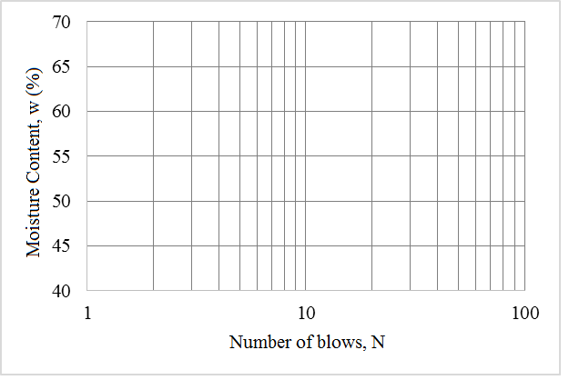

- Classify the soil, for which the grain size distribution and consistency limits are given below, according to Unified Soil Classification System (USCS) and American Association of State Highway and Transportation Officials (AASHTO) Classification System.

SIEVE ANALYSIS
Sieve # | Passing (%)
4 | 95
10 | 91
40 | 85
100 | 71
200 | 68
CONSISTENCY
Liquid Limit, LL (%) | 58
Plastic Limit, PL (%) | 30.1

- A 30 cm high soil sample with a cross-sectional area of 30 cm² is placed in the constant head hydraulic conductivity test setup shown below. A volume of 550 cm3 of water over a time of 300 seconds has been collected in the container next to the test setup. Based on this information:

- Calculate the hydraulic conductivity (permeability) (K) of the given sample.
- Find the total hydraulic head (h), elevation head (z), and pressure head (u/γ_{w}) at points A, B, and C shown in figure.
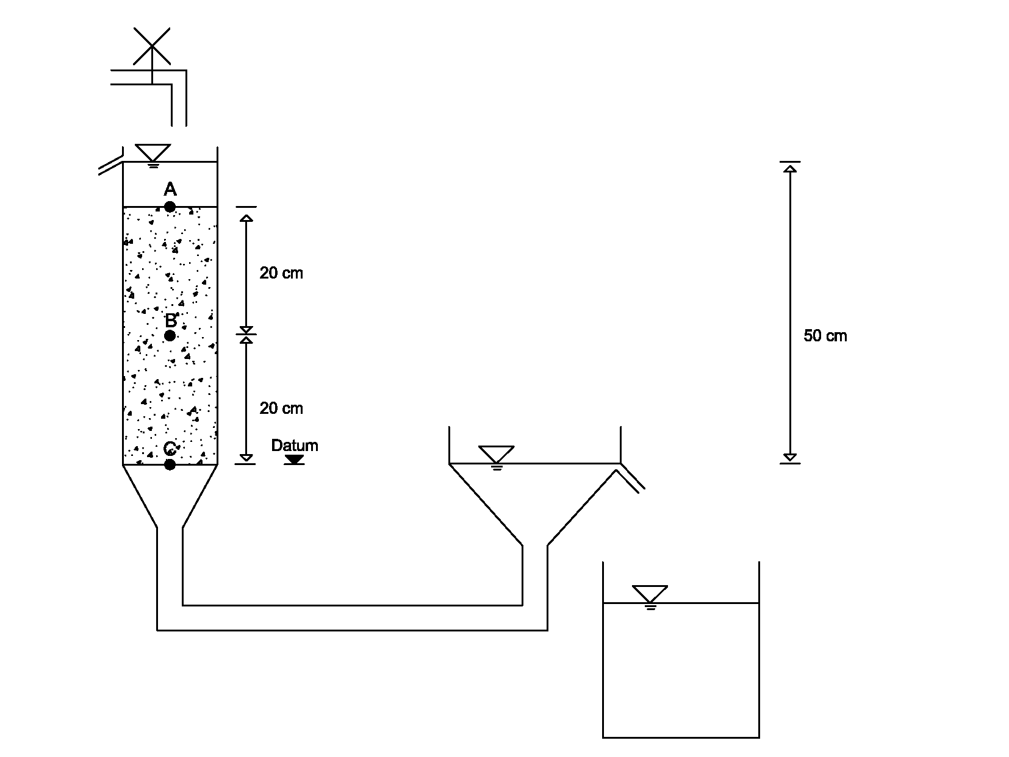

- The flow-net for the water seepage below a sheet pile wall is given below. The hydraulic conductivity (permeability) of the soil is determined as K=6.2x10⁻⁵ m/sec based on laboratory measurements.

- Calculate the amount of water seepage under the sheet pile wall per its unit width.
- Determine if a quick condition/sand boiling occurs at the exit point (A).

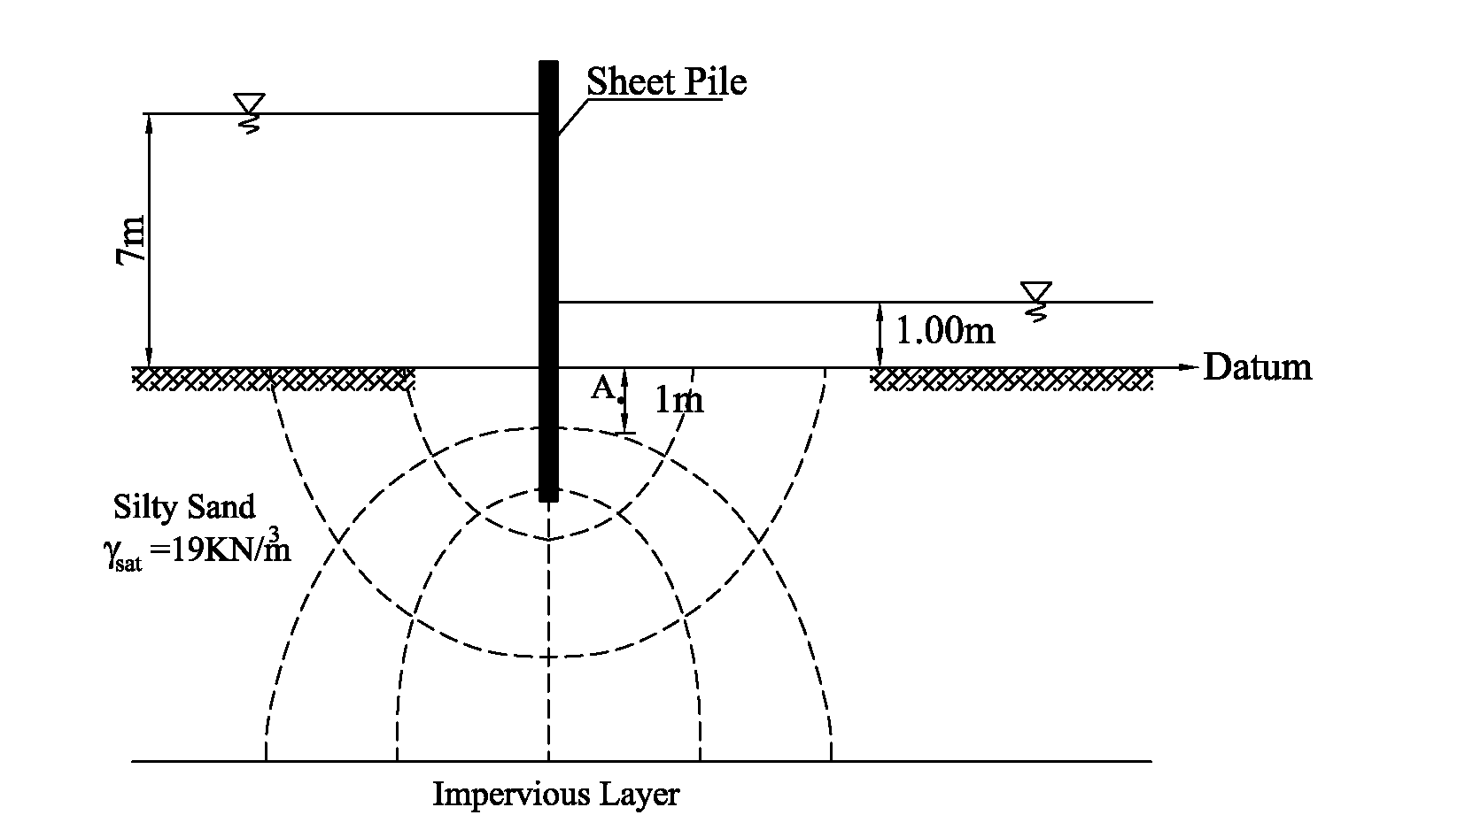

- Given the soil profile below:
- Determine the total vertical pressures (σ), pore-water pressures (u), and effective vertical pressures (σꞌ) at points A and B.
- Calculate the vertical stress increase (Δσ) at the levels of A and B due to a mat foundation, which has a dimension of 15 m x 20 m and is uniformly loaded with a pressure of 150 kPa due to superstructure.
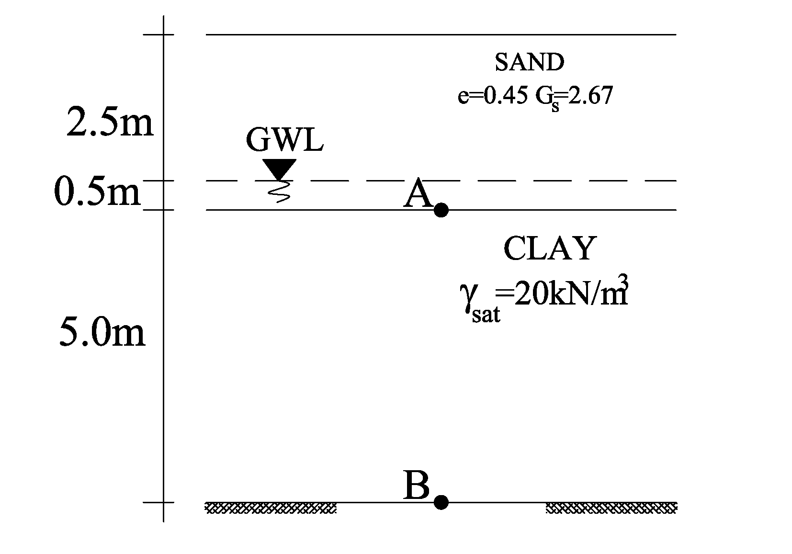

Time 90 minutes. Good Luck…

